
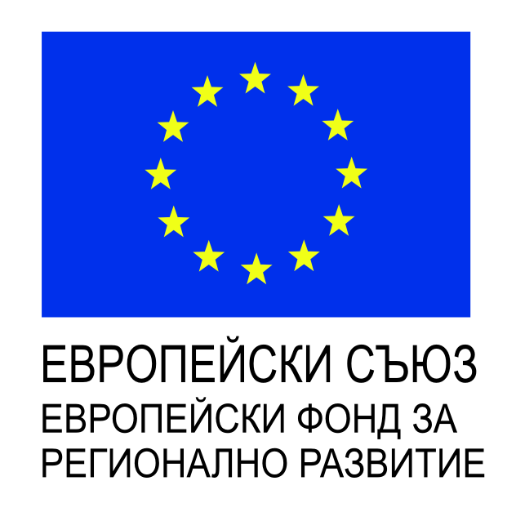
Procedure: BG16RFOP002-2.073 “Support to micro and small enterprises to overcome the economic consequences of the COVID-19 pandemic” under OP “Innovation and Competitiveness 2014-2020”, co-financed by the European Union through the European Regional Development Found and the national budget of the Republic of Bulgaria

Project and main objective: Overcoming the shortage of funding and the lack of liquidity caused by the epidemic outbreak of COVID-19
Contract number: BG16RFOP002-2.073-14251-C01
Beneficiary: VANCOM - LTD
Total value: BGN 10,000, of which BGN 8,500 European and BGN 1.500 national co-financing
Start: 17.09.2020
End: 17.12.2020

